March 26, 2020
Office of the Mayor
Satya Rh odes-Conway , Mayor
City-County Bu il ding, Room 403 210 Martin Luth er Ki ng, J r. Blvd . Madi son, WI 53703
Phone: (608) 266-4611 I Fax: (608) 267-8671
ma.'lQ! @£l!y_9frnadison .com cityofmadison .com

EMERGENCY ORDER

Whereas, on March 23, 2020, I issued an Emergency Proclamation based on the coronavirus pandemic. Under this Emergency Proclamation I am authorized to take any necessary action through ordinance amendments or city policies to mitigate the effects of the pandemic on City workers, residents of, and businesses within the City of Madison. Therefore, effective immediately, and unless noted otherwise, until sixty (60) days after the Director of Public Health Madison and Dane County and the Governor of Wisconsin determine to end the emergency actions they have taken to combat the coronavirus pandemic, I hereby Order the following:

- The City Traffic Engineer may temporarily suspend enforcement of Madison General Ordinance Section 12.122 (Parking, Stopping, and Standing) as deemed appropriate to allow local restaurants to provide take-out food to customers through curbside pick-up.

- Community Development Authority of the City of Madison may suspend the imposition and collection of late lease payment fees for residential and commercial tenants, in its discretion.

- The City will temporarily suspend the assessment and collection of late fees and penalties, to the extent not preempted by state law, for all licenses and permits issued by the City of Madison Clerk's office under Madison General Ordinances.

- The City will temporarily extend the expiration date, to the extent not preempted by state law, of all licenses issued under Madison General Ordinance Section 9.02, which establishes that all City annual licenses shall expire on June 30th of each year, unless otherwise stated. The new expiration date shall be August 31, 2020.

- The City will temporarily suspend the enforcement of Madison General Ordinance Section 12.154(5) and suspend the collection of late payment charges for parking violations.

- Notwithstanding powers and authority given the Equal Opportunities Commission under Madison General Ordinance Section 39.03(10)(b)7., effective immediately and during the period of declared emergency, the Director of the Department of Civil Rights, or designee, shall have the authority to suspend the application of any rule in the Rules of the Equal Opportunities Commission after appropriate notice and after seeing the need for the suspension and putting in place an alternative that protects the rights and privileges of all parties or entities covered by the rule to be suspended.

- Conveyance permits issued under Madison General Ordinance Section 40.08(3) in existence or in existence through the time that the Director of Public Health Madison and Dane County and the Governor of Wisconsin determine to end the emergency actions that they have taken to combat the coronavirus pandemic shall expire one year from the date or issuance or six months from the time that emergency action ends, whichever is greater.

- The City will temporarily suspend the enforcement of Madison General Ordinance Section 33.56(5) to allow the Director of Transportation, Transit Manager, Traffic Engineer, and Parking Manager to take actions related to transportation issues identified in Madison General Ordinance Section 33.56(5)(a)-(c), provided that if the Transportation Commission meets during the coronavirus pandemic the Director of Transportation shall present each action taken pursuant to the authority above for ratification or rescission by the Transportation Commission.

- Until December 31, 2020, Public Health Madison and Dane County is authorized to reduce the fees associated with food and drink establishments, temporary food establishments, tattoo and body piercing, hotels and tourist rooming houses, campgrounds and recreational campgrounds to the 2019 rate and waive late fees and offer renewal fee deferment if not contrary to Wisconsin Department of Agriculture, Trade and Consumer Protection guidelines.

- The City will temporarily suspend the requirement contained in Madison General Ordinance Section 28.098(5)(a)2., that developers hold a pre-application Planned Development Concept Presentation with Urban Design Commission.

- Work permits issued for fire protection systems currently in existence or in existence through the time that the Director of Public Health Madison and Dane County and the Governor of Wisconsin determine to end the emergency actions that they have taken to combat the coronavirus pandemic shall expire one year from the date or issuance or six months from the time that emergency action ends, whichever is greater.

- The Office of Business Resources is authorized with discretion to refund banner permit fees under Madison General Ordinance Section 31.075(2)(a), to any person or organization who has not yet displayed their banner and requests to

cancel their banner reservation because their event has been canceled due to COVID-19, or is canceled in the near future due to COVID-19.

- The requirement contained in Madison General Ordinance Section 4.29(4) that requires that donations to the City over $10,000 may only be accepted upon approval of the Common Council and that all donations must be appropriated by the Common Council if the gift is not otherwise accounted for in an agency's budget is hereby waived. This waiver only applies to donations to assist the City's response to the COVID-10 crisis. The donations are deemed appropriated for use to assist in the response to the COVID-19 crisis. The Department Head will notify the Finance Director and the Mayor of any such donations. The acceptance and appropriation of any such donations will be presented for approval via resolution at the next scheduled Common Council meeting.
- The Parks Department is authorized to refund all permit fees and other associated fees under Madison General Ordinance Section 10.056 that have been pre-paid for Street Use Events if the event is cancelled due to the emergency actions.
- The deadline regarding the timeline to issue or deny street use permits imposed under Madison General Ordinance Section10.056 (5) (f) is hereby waived.

- The provision found in APM 1-1 that requires Common Council approval for the City to indemnify, defend or hold harmless another party, etc., is hereby waived if said language is approved by the City Attorney and Risk Manager and is associated with a contract that is necessary due to the coronavirus pandemic.
- Establishing procedures as outlined in the attached Resolution to expedite emergency contracts and contract amendments necessitated by the COVID-19 emergency.
- All Street Vending License fees for the 2020-2021 vending season, except for Camp Randall High Density Vending and UW Game Day licenses, required under Madison General Ordinances Section 9.13, are hereby waived, and the Office of Business Resources is authorized to issue refunds for all street vending license and late application fees already paid for the 2020-2021 vending season.
- Urban Design Commission's sixty (60) day time limit to review appeals of the Zoning Administrator's decision under the sign code is hereby waived and also allows for the Secretary of the Urban Design Commission, in consultation with the City Attorney on a case-by-case basis, to refer or defer sign code matters that must be reviewed by the Urban Design Commission until a meeting of the Urban Design Commission can be held in compliance with Madison General Ordinance Section 33.01(10)(c).
- The requirement contained in Madison General Ordinance Section 3.12(11)(c) that the Community Development Division issue an RFP for the Emerging Opportunities Program once per year is waived, and the funds allocated for the 2020 EOP program may be reallocated to other contracts or programs to mitigate the effects of the COVID-19 emergency, in the discretion of the COD Director, with notice to the Common Council.
- The City will temporarily suspend the enforcement of Madison General Ordinance Sections 28.183(9)(b) and 28.185(9)(b) to allow the Director of Planning and Community and Economic Development, after consultation with the Alderperson

of the District, to approve an extension of conditional use and demolition approvals for up to thirty-six (36) months from the expiration date. This will allow developers an additional 12 months beyond what is currently allowed under the ordinance.
- City staff are authorized to execute leases, licenses, space use agreements or other form of real estate document for possession of buildings and property suitable to the needs for quarantining employees of the Madison Police Department and Fire Department who are symptomatic for COVID -19, or otherwise test positive for COVID -19 as a result of the performance of their duties.
- The Finance Director is authorized to approve intradepartmental transfers of unencumbered balances of up to $50,000 from the Operating Budget and up to
$250,000 from the Capital Budget.

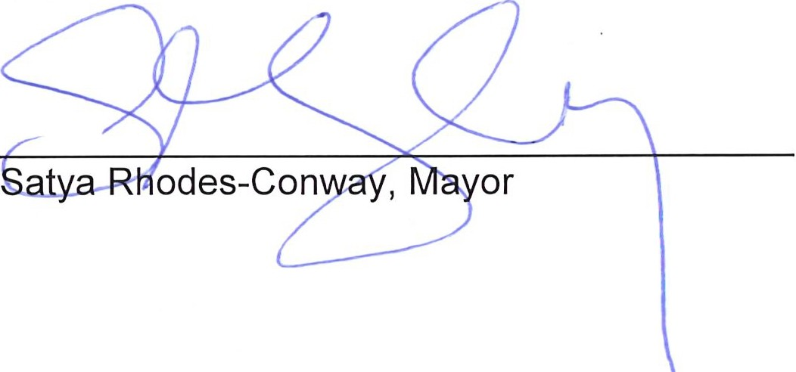
Where these Orders affect a legislative enactment they will be presented for introduction to the Common Council on March 31st.

\ Zb7fi1JD
Date

CITY OF MADISON, WISCONSIN

A RESOLUTION PRESENTED
REFERRED
Establishing procedures to negotiate and execute emergency leases, contracts and contract amendments during the emergency situation.

March 3j, 2020 Adopt under Suspension of the
Rules

Drafted by: Marci Paulsen Date: March 25, 2020

SPONSORS: Mayor Satya Rhodes-Conway

WHEREAS, on March 23, 2020, pursuant to Madison General Ordinance Section 3.19, the Mayor issued an Emergency Proclamation, based on the increasing transmission of COVID-19 within the City of Madison; and

WHEREAS, on March 24, 2020, the Governor of Wisconsin issued Emergency Order #12 ordering individuals to remain home except for Essential Travel; and

WHEREAS, as part of the Governor's Order all Nonessential Businesses are required to close; and

WHEREAS, the closure of numerous businesses throughout the City has the potential to have significant financial impact on residents, necessitating changes to existing City contracts; and

WHEREAS, the impact of the Governor's Order and the circumstances of the pandemic will be widespread upon businesses, community organizations, their employees and the communities they serve, as well as the City's ability to provide essential services; and

WHEREAS, this includes nonprofit and community organizations that currently contract with the City of Madison to provide a variety of services to the residents of Madison; and

WHEREAS, the emergency may also require the City to enter into emergency leases for buildings or land, which would otherwise require individual Common Council approval; and

WHEREAS, to expedite other purchases and contract negotiations in face of the pandemic it is necessary to waive several ordinance and policy requirements; and

WHEREAS, the emergency may also require the City to quickly and efficiently modify existing contracts of all kinds, to extend deadlines or make other changes in response to the emergency, such contracts include but are not limited to purchase contracts, grants to or from the City, and contracts for purchase of services from community service providers, and some of these amendments would normally require Common Council approval and the Mayor and City Clerk's signature;

NOW, THEREFORE, BE IT RESOLVED, the Mayor and Finance Director, upon approval of the City Attorney, may enter into and execute emergency contracts for the possession of real estate, including but not limited to leases of buildings, land, real property and related agreements if necessitated by the public emergency for the protection of the public health, safety and welfare; and shall report the same to the Common Council as soon as practicable; and

Page 2

BE IT FURTHER RESOLVED, this resolution does not impact or change the existing process for emergency contracts that can be made by department heads under the authority of MGO 4.26(4)(c), or those authorized as a public works emergency, or any other existing legal authority for emergency contracting. Such contracts can continue to be made under their respective authority and process; and

BE IT FURTHER RESOLVED, that authority is granted to Department Heads to negotiate and execute contract amendments without Common Council approval, subject to review by the City Attorney and Finance Director or their designees, and subject to the following criteria:

- The contract amendment is needed to:
  - Extend or change a deadline for the contractor or the City, necessitated by the emergency, including extending the end date of the contract;
  - Modify the scope of work or scope of services for reasons due to the emergency; including but not limited to CDD/OCS contracts where the nature of the work is changed in response to the emergency; or
  - Change payment terms for the contractor for reasons due to the emergency; or
  - Make such other changes as deemed necessary due to the emergency; and

- The City Attorney and Finance Director or their designees have approved the form of the amendment and fiscal impact, and such approval may be given via email.

BE IT FURTHER RESOLVED, that the following procedure be used for emergency contracts or amendments executed by a Department Head pursuant to this resolution:

- In addition to the Department Head, the Finance Director/designee shall sign any new contract or amendment that triggers additional expenditure as required by state statute, but need not sign other new contracts or amendments;
- Any requirement for the City Clerk or Risk Manager to sign such amendments or contracts are waived;
- Approval as to form by the City Attorney may be given via email; and
- Department heads shall report all such contracts and contract amendments to the Common Council as soon as practicable.
...
BE IT FlNALLY RESOVLED, that all of the above procedures are effective immediately and shall expire
sixty (60) days after the time that the Director of Public Health Madison and Dane County and the Governor of Wisconsin determine to end the emergency actions that they have taken to combat the coronavirus pandemic.

