Madison Police Department
Michael C. Koval, Chief of Police
City-County Building
211 S. Carroll Street
Madison, Wisconsin 53703
Phone: (608) 266-4022
Fax: (608) 266-4855
police@cityofmadison.com
www.madisonpolice.com

March 9, 2015

County Executive Joe Parisi
VIA HAND-DELIVERY

Re: Madison Police Department Case Number 15-72250

Dear County Executive Joe Parisi~

On Friday night, I’m sure you are aware that the Madison Police Department had an officer involved shooting. Within hours of this incident, many spontaneous and planned protest events began in the downtown area. This letter is not intended to go into the details of that event specifically, but to bring to your attention the very disturbing behavior of one of the Dane County Supervisors.

In the early morning hours of Saturday, March 7, protestors had gathered at the site of the incident in the 1100 block of Williamson Street, and at best their tone can only be described as angry and volatile. At least one Madison Police squad car was damaged during the spontaneous gathering, and the situation was extremely tense. Our officers acted with the appropriate decorum and restraint during these moments, and followed citizen protestors throughout the weekend with a goal of keeping the crime scene, the citizens, and all property safe.

However, around midnight, a group of about 100 protestors moved from the Williamson Street area up to the City-County Building (CCB). These citizens were very angry and were trying to gain access to the building and the police department. Comments such as “kill the cops” and “we have guns too” were yelled frequently. Again, my officers acted with the utmost professionalism and watched over these citizens to ensure their safety, and the safety of all the employees working in this building. We felt comfortable knowing that the City-County Building was locked and closed. We had stationed officers at all the entrances so that people on official business, with a need to enter the building, could do so. However, due to safety concerns, officers were instructed not to allow any protestors entry to the building.

At approximately 12:30am, County Supervisor Leland Pan drove up to the CCB garage doors. He identified himself as a County Supervisor and indicated he had official business within the building. There were three occupants in his car. The officers appropriately allowed him to enter the building, and did not question who was with him in the car. He is a leader of this community and there should be no reason for our officers to question his motives or his need for access to the building. Minutes later, County Supervisor Pan was seen facilitating the opening of doors that allowed hostile protestors into the CCB. He was then seen facilitating the use of the CCB elevators to allow these protestors access to multiple floors of the building. The result of this County Supervisor’s irresponsible behavior resulted in the need to pull additional resources to the CCB to keep order. Our resources were stretched extremely thin, yet the protestors grew in numbers and their anger increased as they neared the police department. I’m sure you are well aware that, in addition to commissioned officers working in this building 24 hours a day, there are civilian employees. Quite frankly, these civilian employees were very scared for their safety.

Let me be clear, County Supervisor Pan’s actions put everyone’s safety at risk - the protestors, police officers and every employee working in the building. This is inexcusable.

As soon as I learned what happened, I telephone Supervisor Pan and told him to come back to the building and turn in his keys and wallet pass card. He attempted to scrape off his vehicle sticker, but I am told he was unable to do so. One of my Assistant Chiefs have made a request to Facilities Management to have both these access cards disabled. I do not believe he should be given his keys or access cards back during these tense times. He has proven to have poor decision-making skills. His keys and pass card were collected and property tagged. A case number was generated and I have directed staff to review this case to determine if any charges are warranted. I wanted to give you this information as a courtesy and to leave it to you to determine what should happen with this property that I believe belongs to Dane County.

Obviously, I am very frustrated that the behavior of a trusted public figure would put so many people’s safety at risk. I do not know what can be done from your office, but the City of Madison Police Department has taken his behavior seriously and will determine what next steps should be taken.

If you have any questions as to what transpired or desire to discuss next steps, please contact my
Administrative Assistant Alyssa Cains to set up necessary meetings. She can be reached at (608) 266-4664 or acains@cityofmadison.com.

Respectfully,
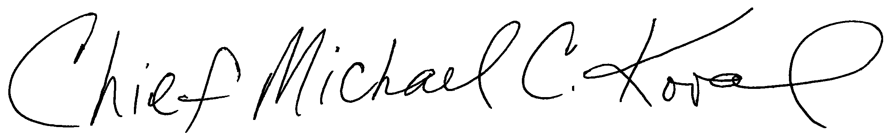

Michael C. Koval
Chief of Police

